**TeamPlus Motorsport Telemetry Platform**

The TeamPlus Motorsport Telemetry Platform was redesigned to address major usability and functionality limitations in the previous system. The original platform lacked a modern user interface, proper file management, playback controls, multi-format downloads, real-time visualisation reliability, and clear documentation for future development. These issues significantly reduced usability for drivers, crew members, and data analysts.

The project modernised the entire platform using Django, JavaScript, HTML/CSS, and AWS infrastructure. The telemetry dashboard was rebuilt with improved responsiveness, cleaner navigation, and enhanced performance on laptop and tablet devices. A fully functional “My Data” section was added, allowing users to upload, download, rename, replay, delete, and share driving session files. Playback-speed control and multi-format video downloading were introduced to support advanced analysis workflows.

The telemetry dashboard was upgraded to visualise tyre temperatures (8 sections per tyre), tyre pressures, brake temperatures, G-force metrics, and live GPS mapping of the vehicle. Although the page was prepared to receive real-time data from the existing API, some integration issues remained on both the API and backend side that require continued refinement. Additionally, the dashboard supports session recording, though recording the map display requires further improvement.

The redesigned version delivers a significantly more user-friendly, flexible, and feature-rich platform. It offers structured UI components, improved documentation, and a scalable foundation for ongoing development. The final outcome aligns with the original project objectives: enhanced usability, expanded telemetry functionality, better performance across devices, and a system ready for future enhancements such as advanced data analysis, AI recommendations, and mobile integration.

**HTML/CSS/JS:**

Before updating:  
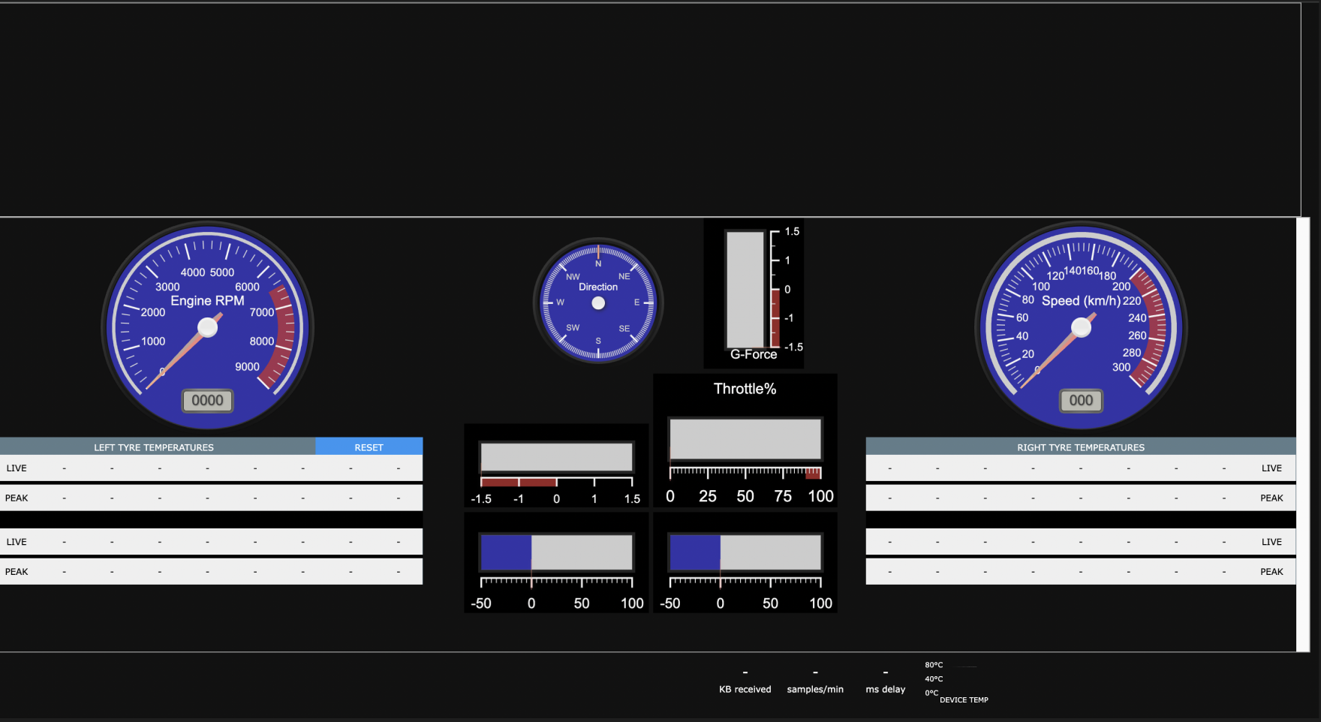

After Update:  
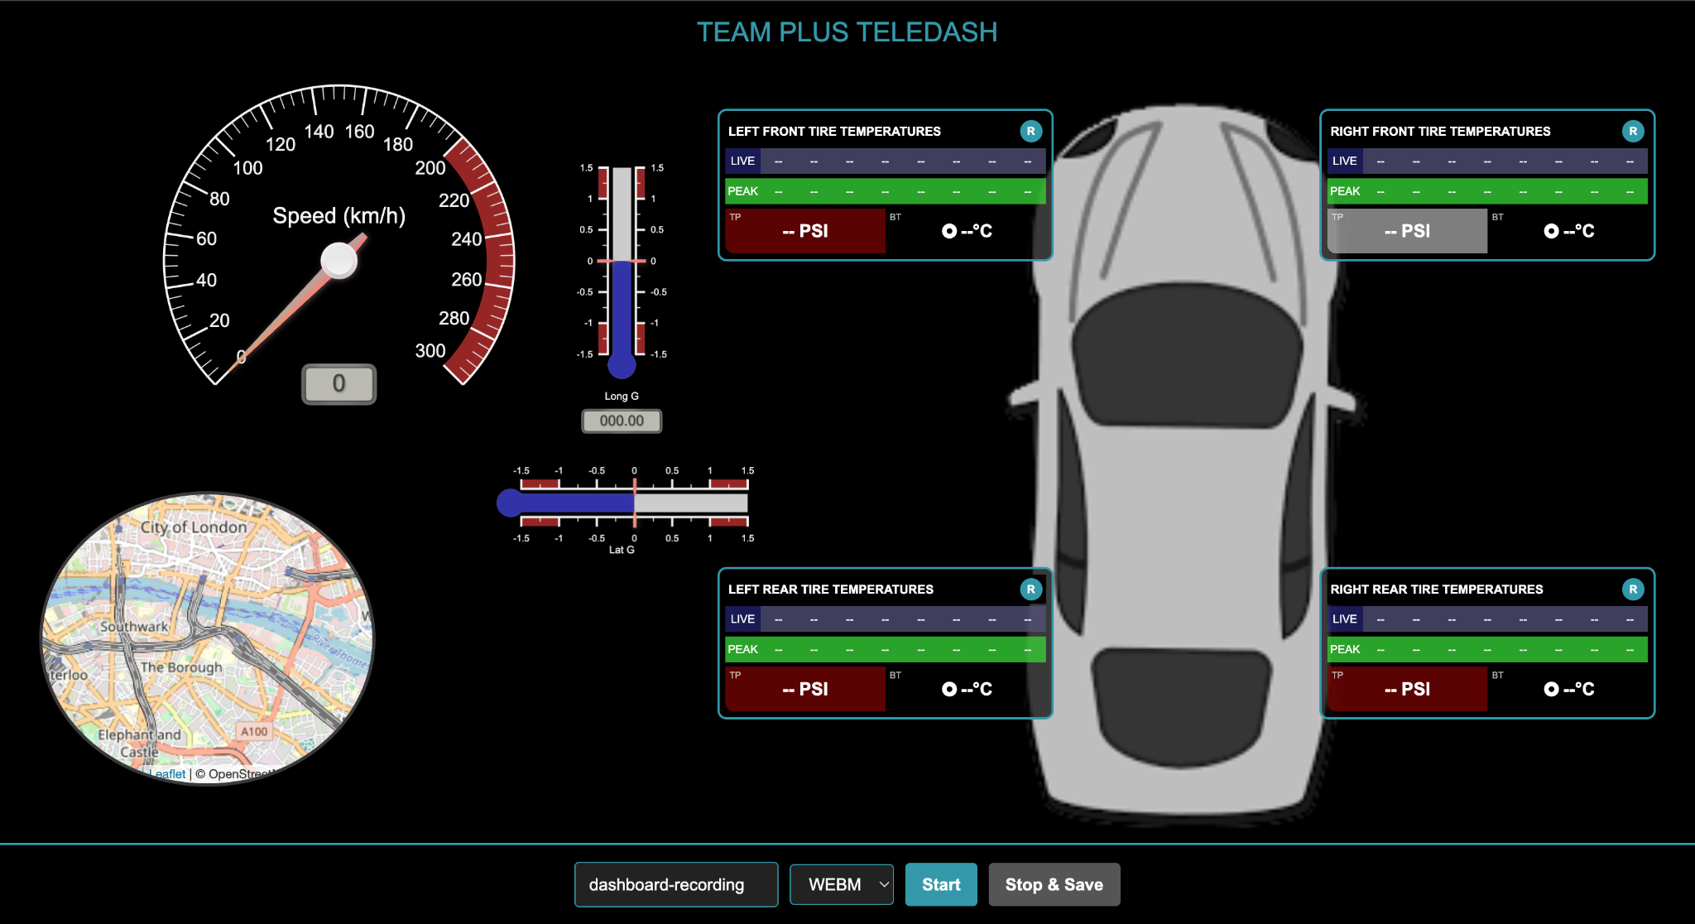

Secondly, we have developed three new HTML files that create the new My Data page on the menu:  
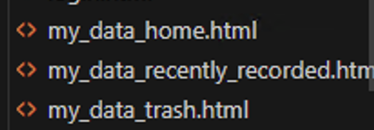

The result of my_data_home.html is:  
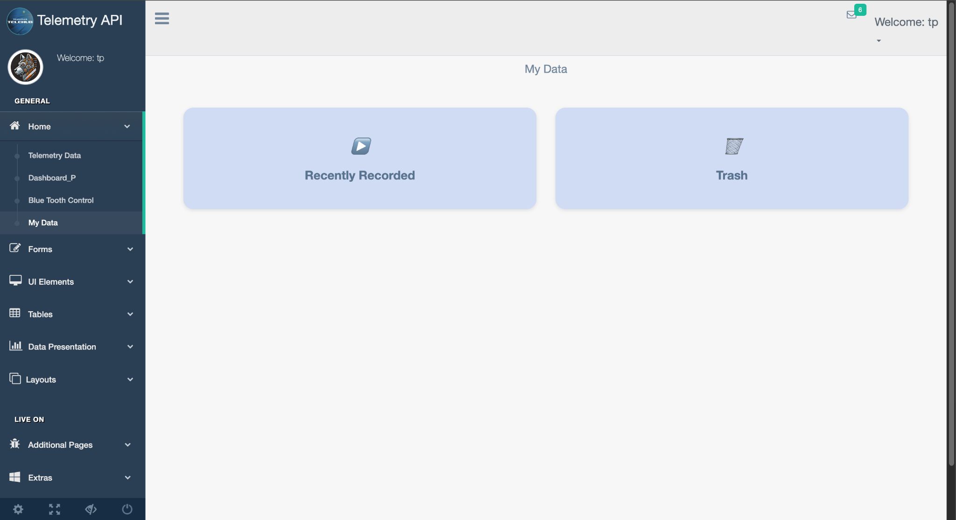

The result of my_data_recently_recorded.html is the page where the recently recorded sessions can be uploaded to, which results in:  
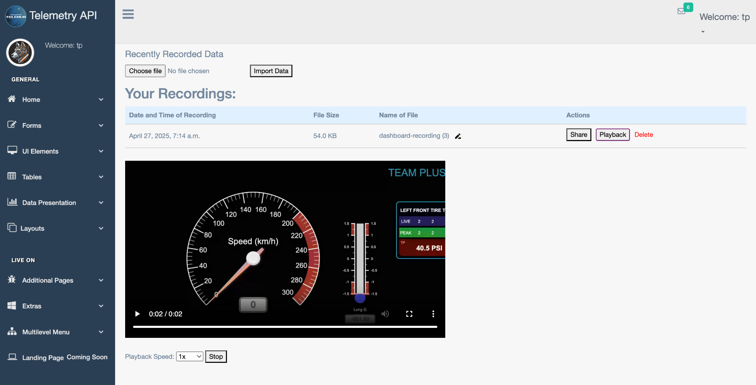

This page gives you the ability to upload, rename, share, playback, and delete your session files.

The my_data_trash.html file will help you to view your trash and review any deleted files, which results in:

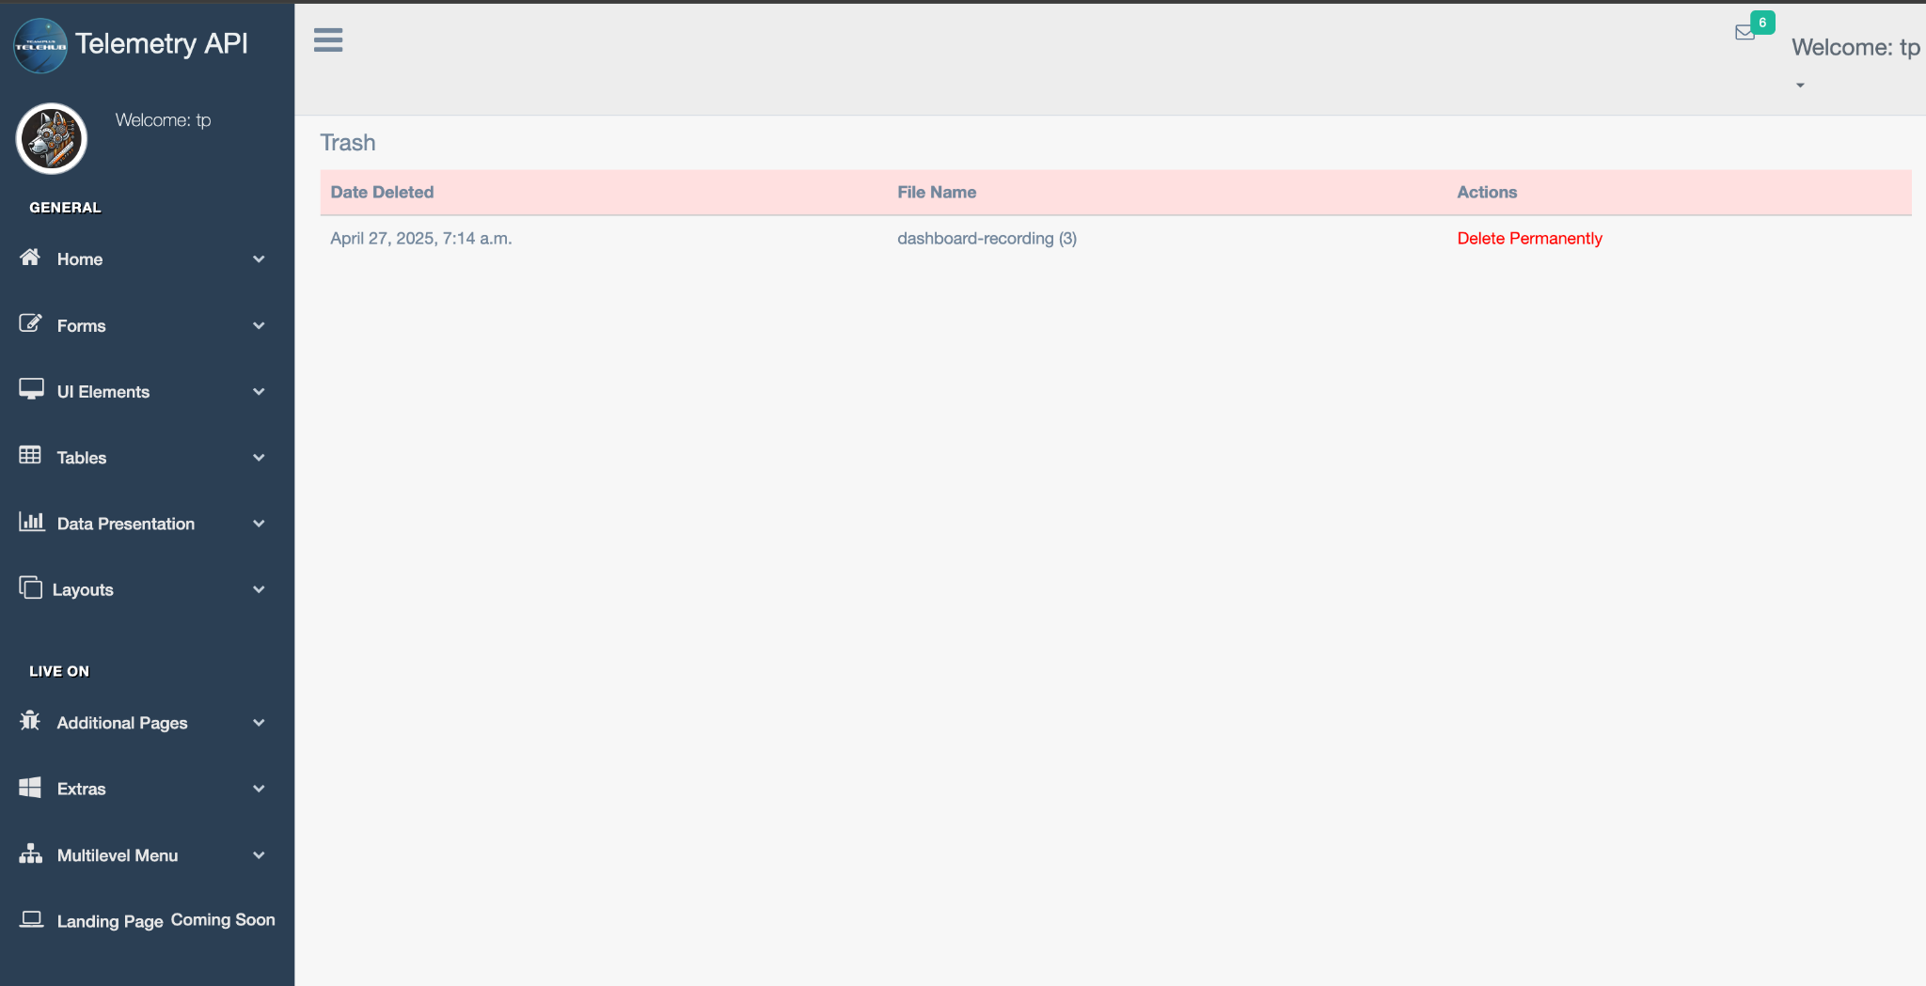

On this page, you can decide whether you can delete this file permanently or not. In the future, there could be an improvement where the user can restore their deleted file.

**Initial Figman Designs being approved:**

**Teledash Laptop and mobile size design:**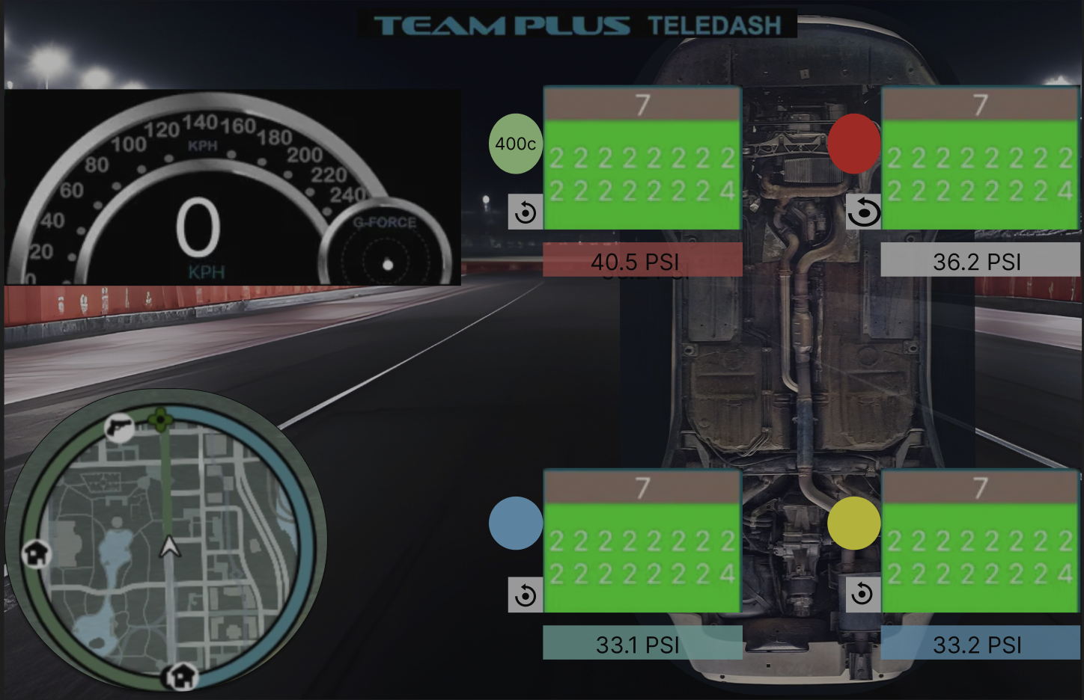

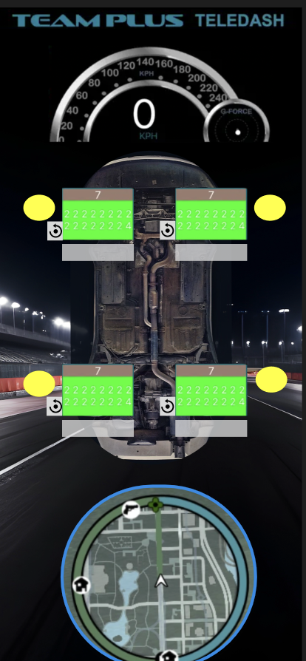

**Dashboard design:  
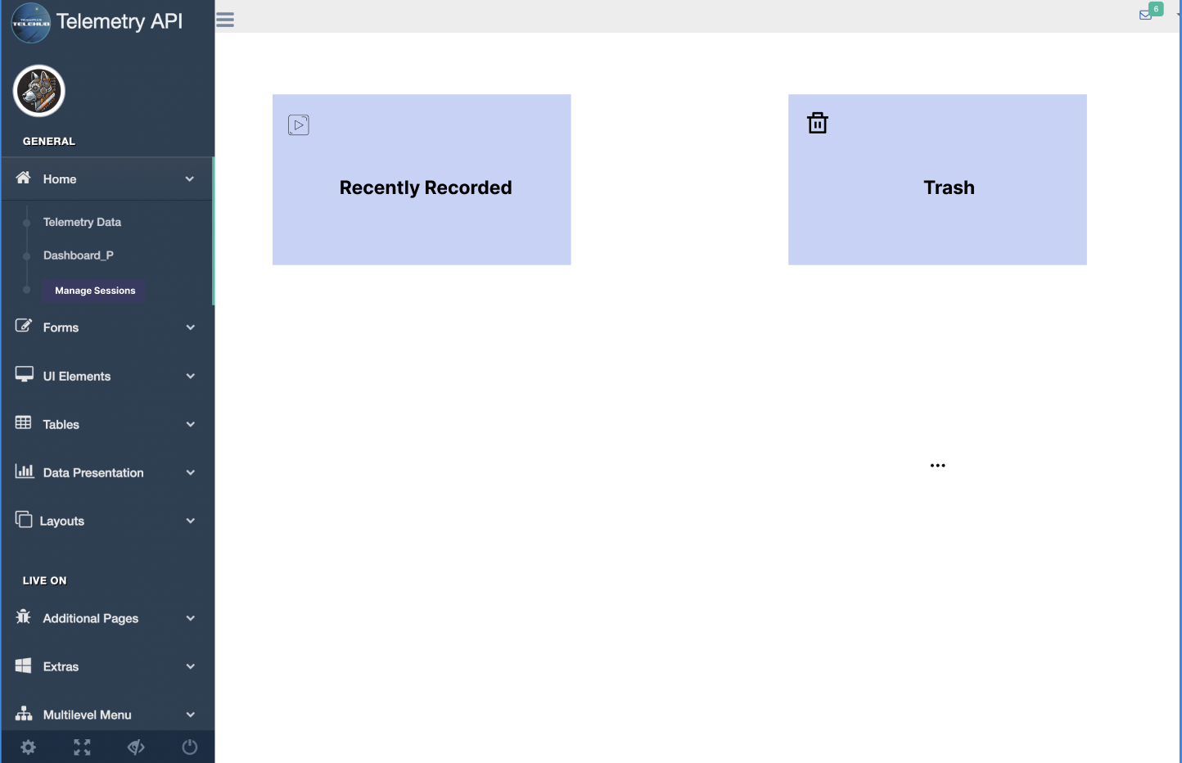**

**Recently Recorded Section:**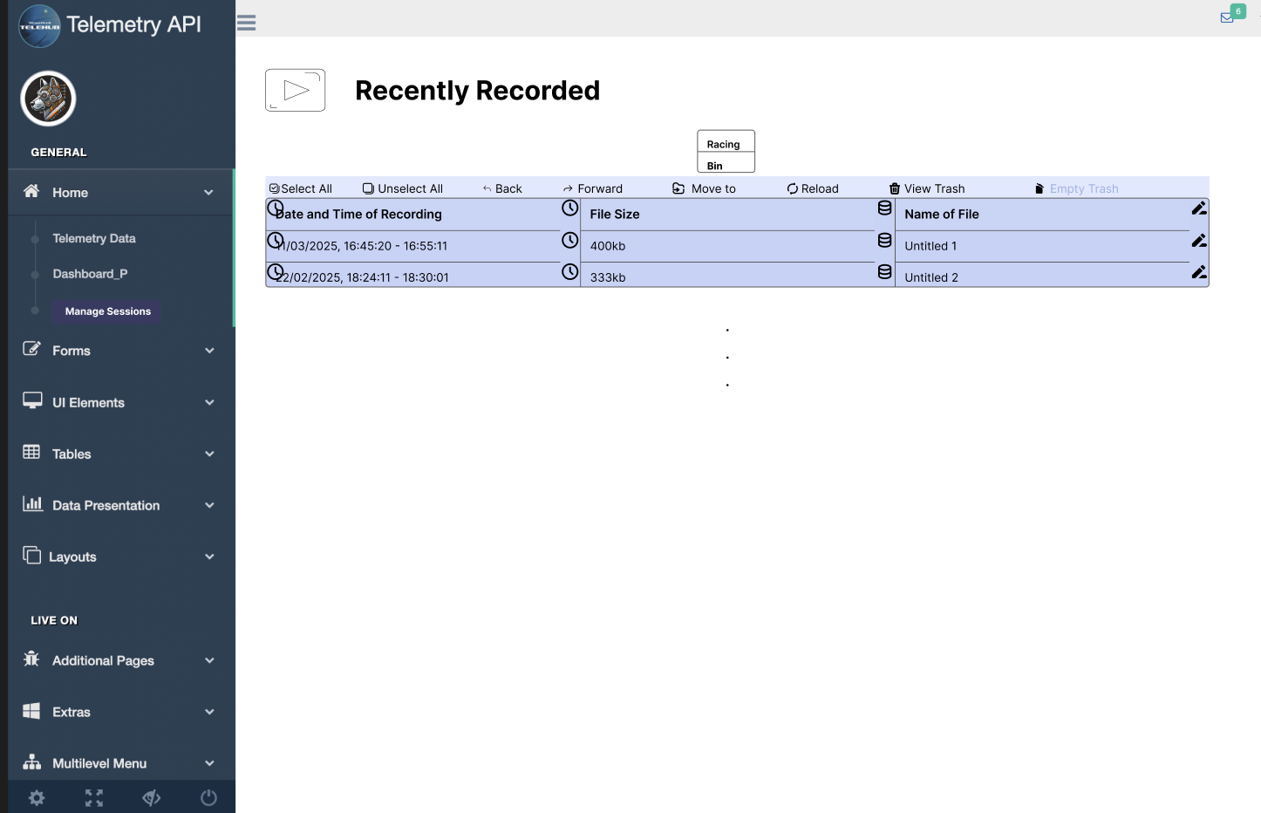

**Trash Section:**